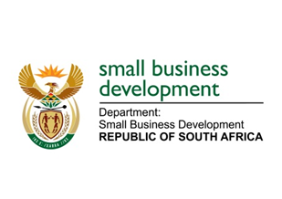

**NATIONAL COUNCIL OF PROVINCES**

**QUESTION FOR ORAL REPLY**

**“230. Mr J J Londt (Western Cape: DA) to ask the Minister of Small Business Development:**

**(a) When will the office of the small and medium-sized enterprises Ombudsman be set up and (b) what will be the functions of such an office?”**

**CO474E**

**REPLY:**

1. It is envisaged that the Small Enterprise Ombud Service will be established in the 2020/21 financial year as soon as the amended legislation is promulgated and proclaimed. The DSBD with the support of the Office of the Chief State Law Adviser has completed the drafting of the amendment Bill for the establishment of a Small Enterprise Ombud Service To date, the draft Bill is undergoing the Social Economic Impact Assessment (SEIAS) process.
2. The main function of the Ombudsman is to resolve disputes between small businesses and other parties which could be other businesses (private) or the state (including SOEs and municipalities) and proposed functions and for the purposes of achieving the objective it will be set for, the Ombudsman will competent to investigate, amongst others, any alleged—
3. unfairness in relation to a contractual arrangement or other legal relationship between the complainant and any other party to the complaint;
4. abuse or unjustifiable exercise of power or unfair or other improper conduct or undue delay in performing in terms of a contractual arrangement or other legal relationship between the complainant and any other party to the complaint; including non or late payment of an SMME
5. act or omission which results in unlawful or improper prejudice to a small enterprise.
6. The Ombud must in any case where a matter has not been settled or a recommendation has not been accepted by all parties concerned, make a final determination,

Further details will be made available when the draft Bill has been considered by Cabinet for both public comments and parliamentary consultation process.